Support Crew Shirt Order Form

[‘Mini Marine’ shirts are optional for the younger grades in your school. If you do not wish to have them, simply delete the wording, shirt example, and sizing table off the form]:
Congratulations! Your son/daughter has been selected as a Support Crew/Mini Marine member of the EcoMarines program at XXXX school. The students will organise and partake in a number of events, activities and/or initiatives with the goal of improving our environmental footprint and educating the community. As a part of this program, you have the option to purchase an EcoMarines Support Crew/Mini Marines shirt.
Cost: $15.00 (including GST)
Method: Please submit this form and payment to (teacher or office) by (date)
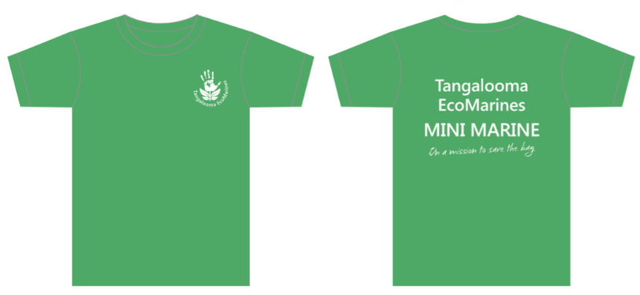
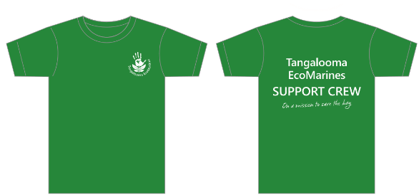

Category | SUPPORT CREW Shirt Size
Kids | 8 | 10 | 12 | 14 | 16
Half Chest (cm) | 40 | 42.5 | 45 | 47.5 | 50
Mens Adult | S | M | L | XL
Half Chest (cm) | 52 | 54.5 | 57 | 60
Ladies Adult  (Slim fit) | 8 | 10 | 12 | 14 | 16
Half Chest (cm) | 42 | 44.5 | 47 | 49.5 | 52

Please circle the shirt size you would like to order:
Category | MINI MARINE Shirt Size
Kids  (Mini Marines) | 2 | 4 | 6 | 8 | 10 | 12
Half Chest (cm) | 32.5 | 35 | 37.5 | 40 | 42.5 | 45

I, _______________________________, would like to order a Mini Marines/Support Crew (select one) shirt for my child ________________________________ in class _______.
Signature: ________________________________ Date: ________________________

