ATTENTION SUPERHEROES
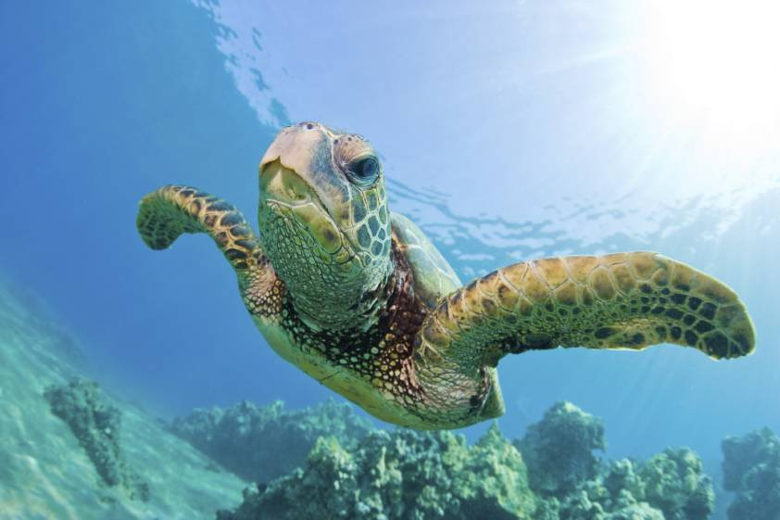
We want your help to protect our water that humans, animals and plants rely on!

Droughts are common in South East Queensland and our population is growing which means we need to make sure that we only use the bare minimum of water.

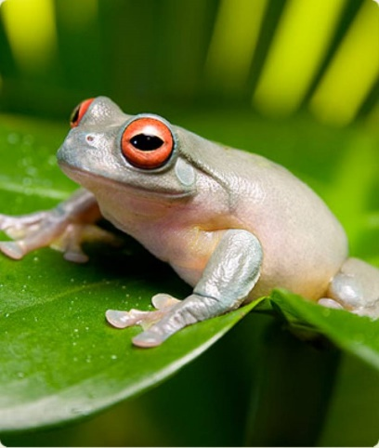
Unitywater
We provide your home, school and community with safe and clean drinking water.

Your mission is to help make sure that this water reaches as many people as possible by creating a catchy slogan about water saving!

Your Mission

Create a slogan (a short quote) that will inspire people to use less water and write it in the box below. These questions may help to form your idea…

- Why should people save water?
- What can people do to save water?
- What is the benefit of people using less water?

Example slogans include:
- Drip, Drop, Drip, Drop. This kind of clock must be stopped
- A drop a day wastes the water away

Student Name: __________________________________________________
Grade: _________________________________________________________
Due Date: [Insert Due Date]
Return Form to: [Insert Place/Person to hand in to]
Write your slogan here:

Return this to the EcoMarines Ambassadors to go in the running to win a prize:

Day Cruise to Tangalooma Island Resort for 1 x adult and 1 x child with dolphin feeding!
Terms and conditions apply.

