Clean Up Club

Thinking about your experience of Clean Up Club, whether you cleaned up as a team with your class or volunteered at lunch time take some time to reflect. These thinking routines will help you through the reflection process. Compare and discuss your thoughts with others.

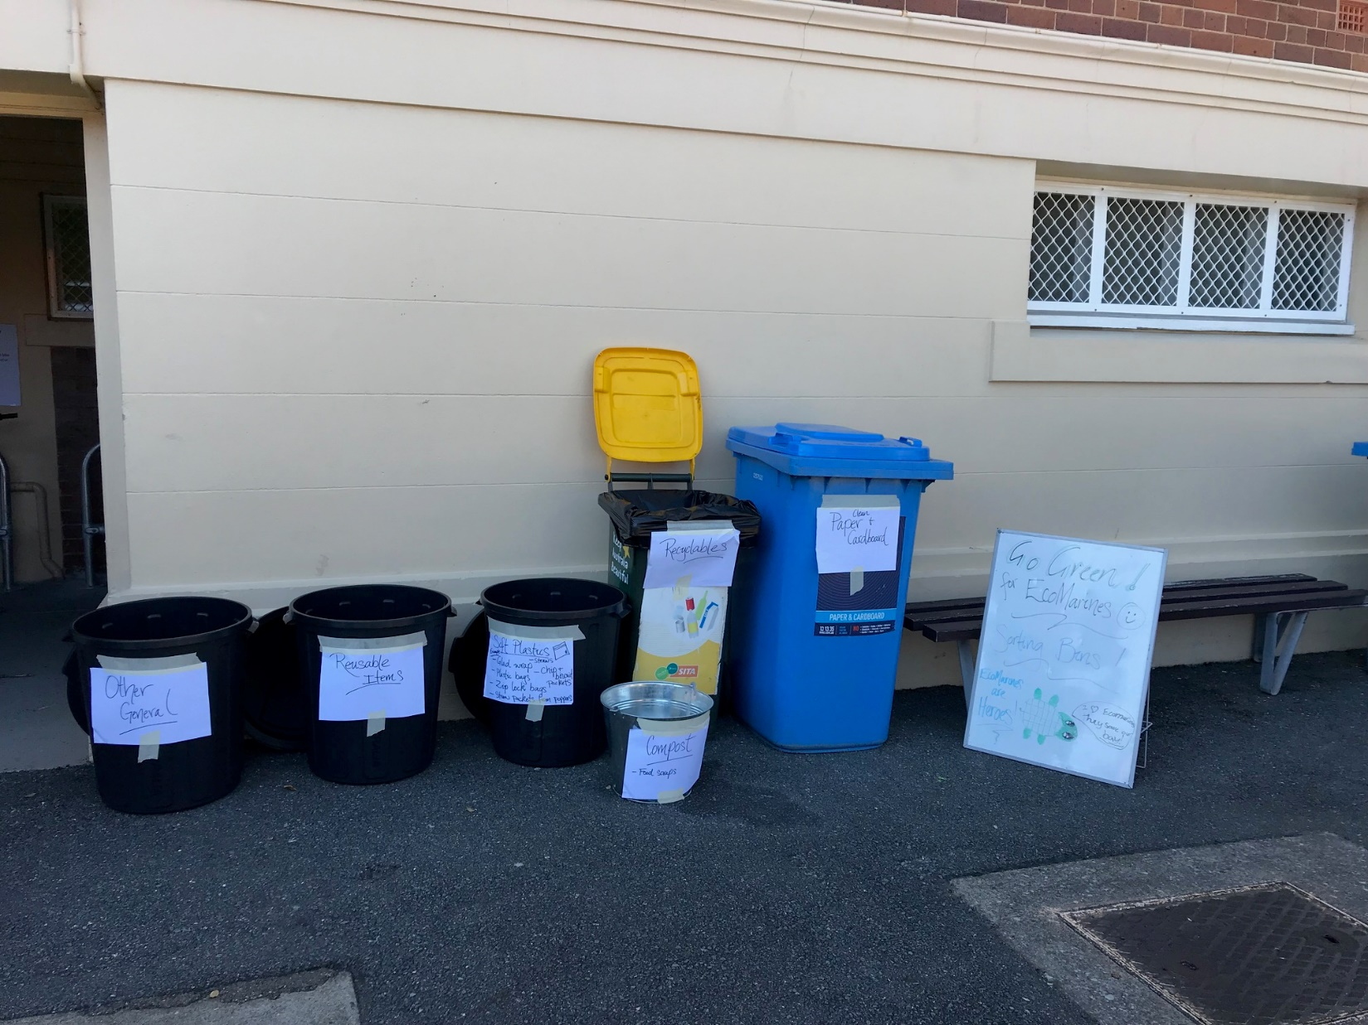

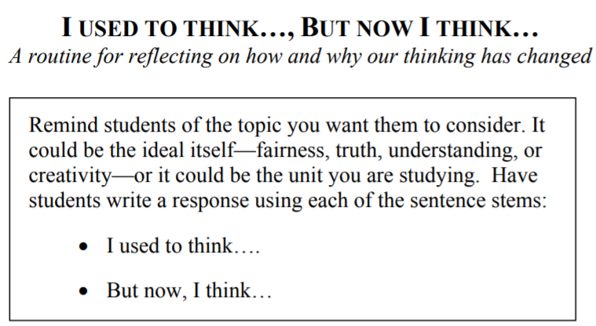

Q1: What did you think about the way Bulimba managed their
I used to think…

Q2: Now that you have participated in Clean Up Bulimba Day, how has your thinking changed?
But now I think…

Q3: What do you think influenced change in your thinking?
My thinking change because…

