Mini Marine Shirt Order Form
Congratulations! Your son/daughter is an official Mini Marine member of the EcoMarines program at XXXX Early Learning Centre. Our centre will be running a number of events, activities and/or initiatives with the goal of improving our environmental footprint and educating the community. As a part of this program, you have the option to purchase an EcoMarines Mini Marines shirt.
Cost: $15.00 (including GST)
Method: Please submit this form and payment to (teacher or office) by (date)
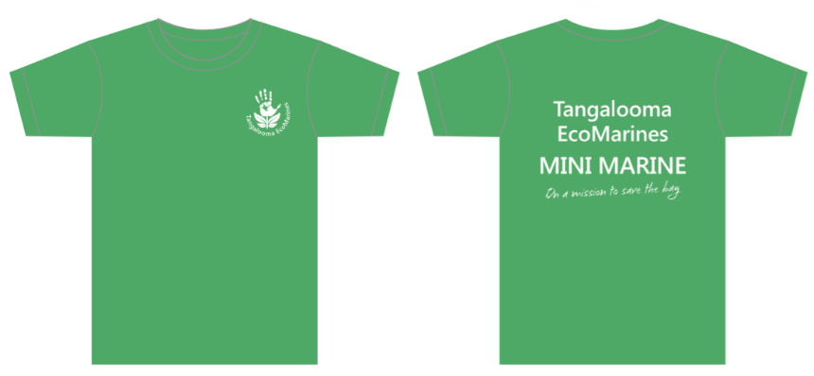

Please circle the shirt size you would like to order:
Category | MINI MARINE Shirt Size
Kids  (Mini Marines) | 2 | 4 | 6 | 8 | 10 | 12
Half Chest (cm) | 32.5 | 35 | 37.5 | 40 | 42.5 | 45

I, _______________________________, would like to order a Mini Marine shirt for my child ________________________________ in class _______.
Signature: ________________________________ Date: ________________________

