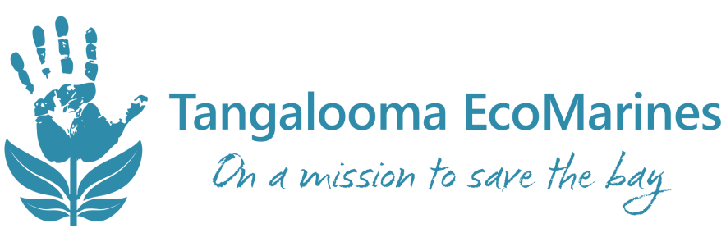
ENVIRONMENTAL ACTION PLAN 2020
MONTH | SECTION  (communication, community, nature/food, water, waste, recycle or energy) | IDEA | IMPLEMENTATION PLAN / NOTES | DATE  COMPLETED (tick box beside item once complete)
E.g. January | Waste | Wrapper Free Wednesday | Show students the Wrapper Free Wednesday video online. Write letter to send to parents and include lunch suggestions from EcoMarines. Discuss contents of lunch with children each Wednesday to explain what things are (plastic, metal, reusable container, paper) | 5th Feb 2020

