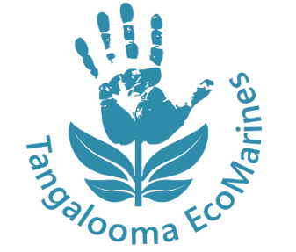
ECOMARINES DIY CLEANING PRODUCTS

Harsh chemicals inside cleaning products can contaminate water ways. These are some simple DIY cleaning products that are much safer for the environment and are cheaper than buying name brand products. Get the kids involved for some creative and useful fun!

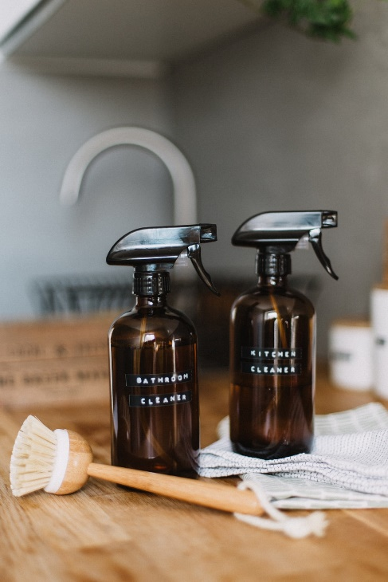
ALL ROUND SPRAY CLEANER
1. Mix one cup white vinegar with one cup water
2. Add this solution to an empty spray bottle
3. Add lemon rind, rosemary or essential oils for a nice scent
4. Shake and spray!

MICROWAVE CLEANER
1. Pour vinegar and lemon juice into a microwave safe cup
2. Put the cup in the microwave and let it run for two minutes
3. Leave the door closed for a few minutes then open and wipe down the inside

DIY DISH-WASHING TABLETS
1. Mix ¼ cup bicarb soda, ¼ cup citric acid, ¼ teaspon sea salt, and a tablespoon of corn starch
2. Add ½ a teaspoon of liquid soap and a few drops of your favourite essential oil
3. Mix everything together and place into ice cube moulds then dry for 24 hours... EASY!

You can also purchase some eco-friendly cleaning products! Check out your local health food store or similar alternatives.

